New Unity Movement

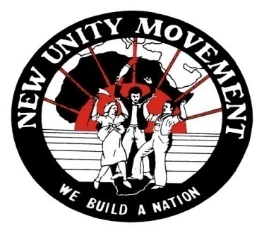
The Bulletin
(An official publication of the New Unity Movement)

Vol. 22 No.1 November 2015
CONTENTS
1 | Proposal of Panel of Papers Presented by the NUM | 1
2 | Class Roots of Racialism in South Africa | 2
3 | Why was Racialism never dismantled in South Africa | 12
4 | The Unity Movement and Non-racialism in Sport | 27
5 | The CATA and the TLSA the legacy and promotion of Non-racialism | 51

Printed and Issued by the Publications Bureau of the New Unity Movement (NUM)

_______________________________________________________________________________________________________________________________________
Address all Correspondence to the Secretariat: New Unity Movement PO Box 1455 Uitenhage 6230
E-Mail: hampet@worldonline.co.za / titusf@cput.ac.za
Faxmail: 086 671 4234
083 459 5736 / 079 695 0577

…. Our people suffered from a slave mentality which was a barrier to all progress. Slaves cannot conduct a protracted struggle against their masters until they begin to see themselves as human beings. In our approach to this problem we had to show them that without their consent and participation it was not possible for the master race to keep them in bondage, and that they, particularly the black intellectuals, were the necessary cogs in the machinery for their own oppression. It was out of this that arose the policy of non-collaboration.
IB Tabata – In a letter to President Kwame Nkrumah, 1964

Published and Issued by the New Unity Movement

______________________________________________________________________________________________
Address all Correspondence to the Secretariat: New Unity Movement PO Box 1455 Uitenhage 6230
E-Mail: hampet@worldonline.co.za / titusf@cput.ac.za
Faxmail: 086 671 4234
083 459 5736 / 079 695 0577

